QUESTION 1 : Write a menu-driven program in C to perform the following operations in an integer array allocated memory dynamically. The list may grow or shrink compared to the initial allocation as and when required. Multiple operations may be performed on the existing list without recompiling/re-executing the program. The individual operation should be implemented using a single function.
List of operations:
a) Create
b) Display the entire list
c) Count (total number of elements in the list)
d) Reverse the list (reversed list should be stored in the same array)
e) Index of a given element (all indices if there are duplicate entries)
f) Indexed element
g) Insert
h) Delete
i) Merge
j) Split
k) Sort

SORCE CODE :
#include <stdio.h>
#include <stdlib.h>
#include <time.h>
#include <stdbool.h>
#define MAX 20

typedef struct Array{
int* arr;
int n;
}Array;

Array create(int n) {
Array ptr;
ptr.arr = (int*)malloc(n * sizeof(int));

if (ptr.arr == NULL) {
printf("Memory allocation failed.\n");
ptr.n = 0;
return ptr;
}

ptr.n = n;
printf("Generating random elements : ");

for (int i = 0; i < ptr.n; i++) {
ptr.arr[i] = rand() % 900 + 100;
printf("%d ", ptr.arr[i]);
}

printf("\nArray created successfully.\n");
return ptr;
}

void display(Array ptr) {
if (ptr.arr == NULL || ptr.n == 0) {
printf("Array is Empty.\n");
return;
}

printf("[ ");
for (int i = 0; i < ptr.n; i++)
printf("%d ", ptr.arr[i]);
printf("]\n");
}

int count(Array ptr) {
return ptr.n;
}

void reverse(Array *ptr) {
if (ptr->arr == NULL || ptr->n == 0) {
printf("Array is Empty.\n");
return;
}

int i = 0, j = ptr->n - 1;

while (i < j) {
int temp = ptr->arr[i];
ptr->arr[i] = ptr->arr[j];
ptr->arr[j] = temp;
i++;
j--;
}

printf("Successfully reversed.\n");
}

Array indexOf(Array ptr, int target) {
Array pos = {NULL,0};

if (ptr.arr == NULL || ptr.n == 0) {
printf("Array is Empty.\n");
return pos;
}

pos.arr = (int *)malloc(ptr.n * sizeof(int));

if (pos.arr == NULL)
return pos;

for (int i = 0; i < ptr.n; i++) {
if (ptr.arr[i] == target) {
pos.arr[pos.n] = i;
pos.n++;
}
}

if (pos.n == 0) {
free(pos.arr);
pos.arr = NULL;
} else {
int *temp = realloc(pos.arr, pos.n * sizeof(int));
if (temp != NULL)
pos.arr = temp;
}

return pos;
}

int getElement(Array ptr, int idx) {
if (ptr.arr == NULL)
return -1;

if (idx < 0 || idx >= ptr.n)
return -2;

return ptr.arr[idx];
}

Array insert(Array ptr, int val) {
if (ptr.arr == NULL || ptr.n == 0) {
ptr.arr = (int *)malloc(sizeof(int));
if (ptr.arr == NULL)
return ptr;

ptr.arr[0] = val;
ptr.n = 1;
} else {
int *temp = realloc(ptr.arr, (ptr.n + 1) * sizeof(int));
if (temp == NULL) {
printf("Memory allocation failed.\n");
return ptr;
}

ptr.arr = temp;
ptr.arr[ptr.n] = val;
ptr.n++;
}

printf("Successfully Inserted.\n");
return ptr;
}

Array delete(Array ptr, int *val) {
if (ptr.arr == NULL || ptr.n == 0) {
printf("Array is Empty.\n");
return ptr;
}

*val = ptr.arr[ptr.n - 1];

if (ptr.n == 1) {
free(ptr.arr);
ptr.arr = NULL;
ptr.n = 0;
} else {
ptr.n--;
int *temp = realloc(ptr.arr, ptr.n * sizeof(int));
if (temp != NULL)
ptr.arr = temp;
}

return ptr;
}

Array merge(Array *ptr1, Array *ptr2) {
Array new = {NULL,0};

if (ptr1->arr == NULL && ptr2->arr == NULL)
return new;

if (ptr1->arr == NULL)
return *ptr2;

if (ptr2->arr == NULL)
return *ptr1;

new.n = ptr1->n + ptr2->n;
int *temp = realloc(ptr1->arr, new.n * sizeof(int));

if (temp == NULL) {
printf("Merge failed.\n");
new.n = 0;
return new;
}

new.arr = temp;

for (int i = 0; i < ptr2->n; i++)
new.arr[ptr1->n + i] = ptr2->arr[i];

ptr1->arr = NULL;
ptr1->n = 0;

ptr2->arr = NULL;
ptr2->n = 0;

printf("Merge Done.\n");
return new;
}

void split(Array *ptr1, Array *ptr2, int idx) {
if (ptr1->arr == NULL) {
printf("Array is Empty.\n");
return;
}

if (idx < 0 || idx >= ptr1->n) {
printf("Invalid Index.\n");
return;
}

ptr2->n = ptr1->n - idx;
ptr2->arr = (int *)malloc(ptr2->n * sizeof(int));

if (ptr2->arr == NULL)
return;

for (int i = 0; i < ptr2->n; i++)
ptr2->arr[i] = ptr1->arr[idx + i];

ptr1->n = idx;
int *temp = realloc(ptr1->arr, ptr1->n * sizeof(int));

if (temp != NULL || ptr1->n == 0)
ptr1->arr = temp;
}

void sort(Array *ptr) {
if (ptr->arr == NULL || ptr->n == 0)
return;

for (int i = 1; i < ptr->n; i++) {
int key = ptr->arr[i];
int j = i - 1;

while (j >= 0 && ptr->arr[j] > key) {
ptr->arr[j + 1] = ptr->arr[j];
j--;
}
ptr->arr[j + 1] = key;
}
}

int main()
{
srand(time(NULL));

Array ptr[MAX];
for(int i=0;i<MAX;i++){
ptr[i].arr=NULL;
ptr[i].n=0;
}

int current=-1;
int total=0;
bool run=true;

while(run)
{
printf("\n=========================================\n");
if(current==-1)
printf("Current Array : None\n");
else
printf("Current Array : A%d (Size=%d)\n",current,ptr[current].n);
printf("Total Arrays : %d/%d\n",total,MAX);
printf("=========================================\n");

printf("1. Create New Array\n");
printf("2. Switch Current Array\n");
printf("3. Display Current\n");
printf("4. Count\n");
printf("5. Reverse\n");
printf("6. Index Of\n");
printf("7. Get Element\n");
printf("8. Insert\n");
printf("9. Delete Element\n");
printf("10. Merge With Another Array\n");
printf("11. Split Current Array\n");
printf("12. Sort\n");
printf("13. Display All Arrays\n");
printf("14. Delete Current Array Entirely\n");
printf("15. Exit\n");
printf("Choice : ");

int ch;
if(scanf("%d",&ch) != 1) break;

if(ch!=1 && ch!=2 && ch!=13 && ch!=15 && current==-1){
printf("No active array. Create one first.\n");
continue;
}

switch(ch)
{
case 1:{
if(total==MAX){ printf("Maximum arrays reached.\n"); break; }
int n;
printf("Size : ");
scanf("%d",&n);
ptr[total]=create(n);
current=total;
total++;

printf("Resulting Array A%d: ", current);
display(ptr[current]);
break;
}

case 2:{
if(total==0){ printf("No arrays.\n"); break; }
printf("Existing Arrays\n");
for(int i=0;i<total;i++)
printf("A%d (Size=%d)\n",i,ptr[i].n);
printf("Choose : ");
scanf("%d",&current);
if(current<0||current>=total){
printf("Invalid.\n");
current=0;
}
break;
}

case 3: display(ptr[current]); break;
case 4: printf("Count = %d\n",count(ptr[current])); break;
case 5:
display(ptr[current]);
reverse(&ptr[current]);
display(ptr[current]);
break;

case 6:{
int t;
printf("Target : ");
scanf("%d",&t);
Array pos=indexOf(ptr[current],t);
if (pos.arr != NULL) {
printf("Found at indexes: ");
display(pos);
}else if (pos.arr == NULL && ptr[current].arr != NULL) {
printf("Item Not Found.\n");
}
free(pos.arr);
break;
}

case 7:{
int idx;
printf("Index : ");
scanf("%d",&idx);
int x=getElement(ptr[current],idx);
if(x==-1) printf("Array Empty\n");
else if(x==-2) printf("Index Out of Bound\n");
else printf("Element=%d\n",x);
break;
}

case 8:{
int v;
printf("Value : ");
scanf("%d",&v);
ptr[current]=insert(ptr[current],v);
display(ptr[current]);
break;
}

case 9:{
int v=-1;
ptr[current]=delete(ptr[current],&v);
if(v!=-1) printf("Deleted=%d\n",v);
display(ptr[current]);
break;
}

case 10:{
int other;
printf("Merge with Array : ");
scanf("%d",&other);
if(other<0||other>=total||other==current){ printf("Invalid.\n"); break; }

ptr[current]=merge(&ptr[current],&ptr[other]);
for(int i = other; i < total - 1; i++) {
ptr[i] = ptr[i+1];
}
total--;
if(current > other) {
current--;
}
printf("Merged Array A%d: ", current);
display(ptr[current]);
break;
}

case 11:{
if(total==MAX){ printf("Maximum arrays reached.\n"); break; }
int idx;
printf("Split Index : ");
scanf("%d",&idx);

if (idx < 0 || idx >= ptr[current].n) {
printf("Invalid Index.\n");
break;
}

split(&ptr[current],&ptr[total],idx);
int split_index = total;
total++;
printf("Split Result -> A%d (Original Left): ", current);
display(ptr[current]);
printf("Split Result -> A%d (New Right): ", split_index);
display(ptr[split_index]);

current = split_index;
break;
}

case 12:
sort(&ptr[current]);
display(ptr[current]);
break;

case 13:
for(int i=0;i<total;i++){
printf("A%d : ",i);
display(ptr[i]);
}
break;

case 14:
free(ptr[current].arr);
for(int i = current; i < total - 1; i++) {
ptr[i] = ptr[i+1];
}
ptr[total-1].arr = NULL;
ptr[total-1].n = 0;

total--;
printf("Current array deleted completely.\n");

if(total == 0) {
current = -1;
} else if (current >= total) {
current = total - 1;
}
break;

default:
run=false;
printf("Exiting Program...\n");
}
}

for(int i=0;i<MAX;i++)
free(ptr[i].arr);

return 0;
}

OUTPUT :
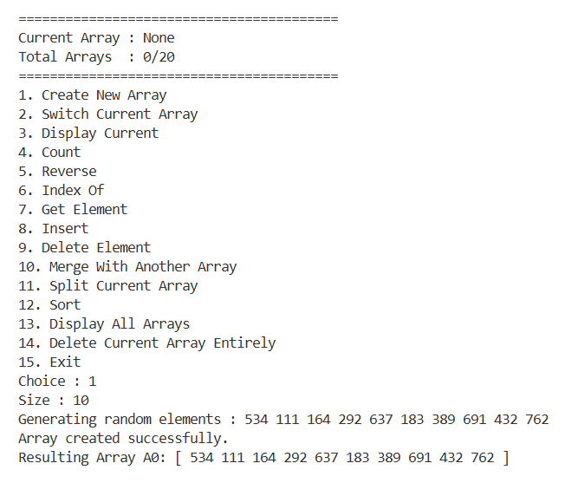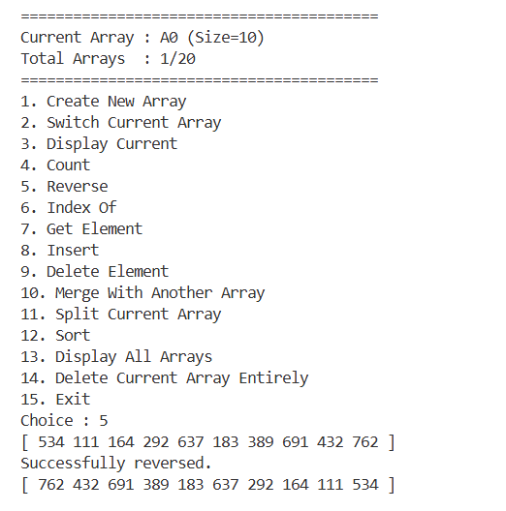
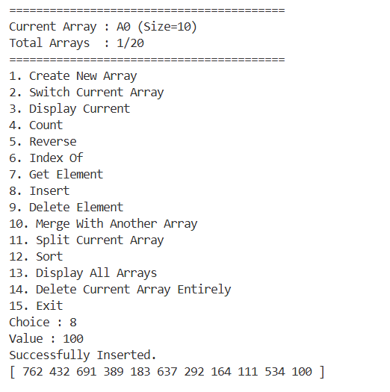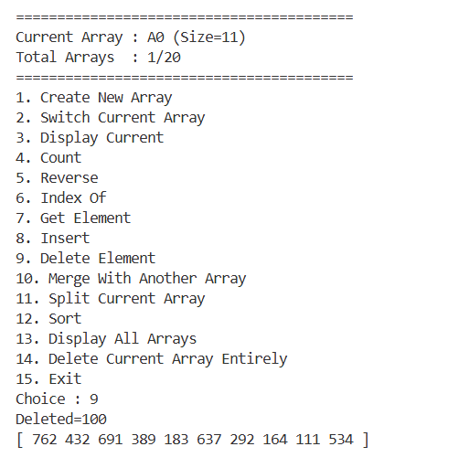

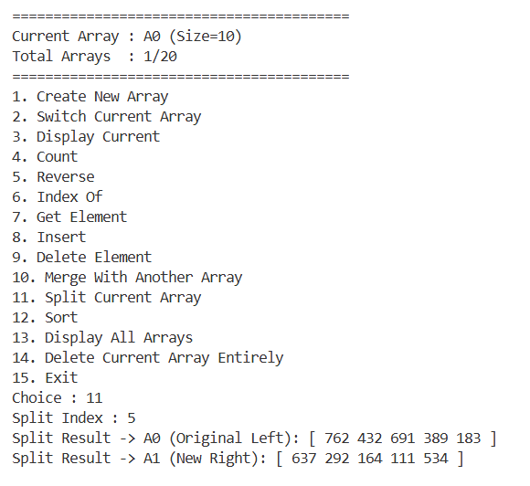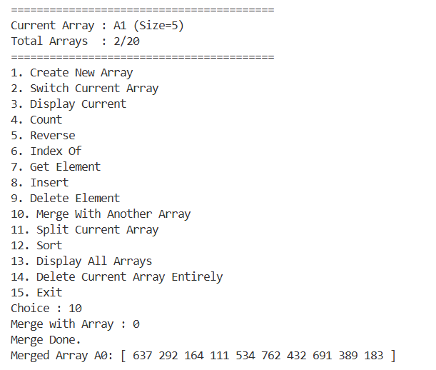

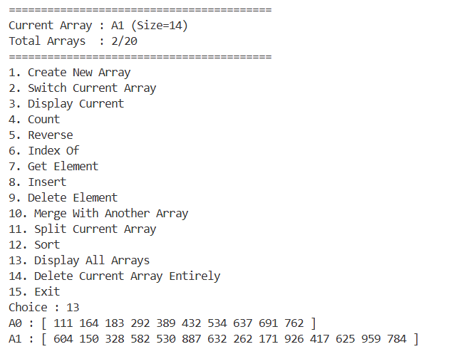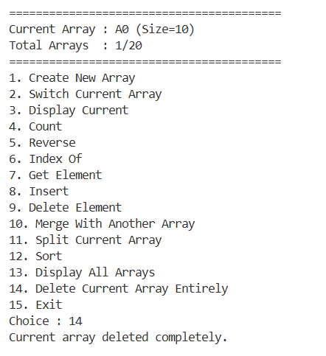
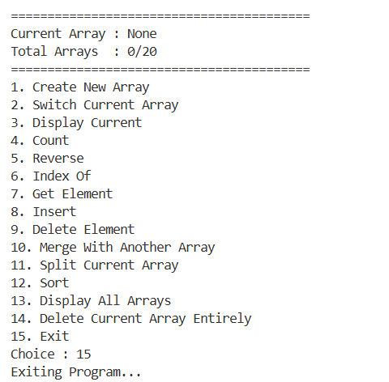
QUESTION 2: Write a menu-driven program that performs the following on a single linked list. (Write a function for each of the operations)
I. Create a linked list.
II. Print the content of the list.
III. Insert an element at the front of the list
IV. Insert an element at the end of the list
V. Insert a node after the kth node.
VI. Insert a node after the node (first from the start) containing a given value.
VII. Insert a node before the kth node.
VIII. Insert a node before the node (first from the start) containing a given value.
IX. Delete the first node.
X. Delete the last node.
XI. Delete a node after the kth node.
XII. Delete a node before the kth node.
XIII. Delete the kth node.
XIV. Delete the node(first from the start) containing a specified value.
XV. Find the reverse of a list(not just printing in reverse)
XVI. Sort the list
XVII. Search a given element
XVIII. Merge two lists; those are in ascending order.
XIX. Concatenate two list
XX. Find if two lists are equal(Boolean output)

SOURCE CODE :
#include <stdio.h>
#include <stdlib.h>

typedef struct Node{
int val;
struct Node *next;
}Node;

void freeList(Node* head) {
Node* temp;
while (head != NULL) {
temp = head;
head = head->next;
free(temp);
}
}

//1. create
Node* create(int val) {
Node* head = (Node*)malloc(sizeof(Node));

if (head == NULL) {
printf("Memory Allocation Failed.\n");
return NULL;
}

head->next = NULL;
head->val = val;
return head;
}

//2. print
void print(Node* head) {
if (head == NULL) {
printf("List is Empty.\n");
return;
}
Node* temp = head;
printf("[%p] -> ", temp);
while (temp != NULL)
{
if (temp->next == NULL) {
printf("[%d | %p]", temp->val, temp->next);
} else {
printf("[%d | %p] -> ", temp->val, temp->next);
}
temp = temp->next;
}
printf("\n");
}

//3. insert at front
Node* insertFront(Node* head, int val) {
if (head == NULL) return create(val);

Node* newNode = (Node*)malloc(sizeof(Node));
if (newNode == NULL) {
printf("Memory Allocation Failed.\n");
return head;
}
newNode->val = val;
newNode->next = head;
head = newNode;
return head;
}

//4. insert at end
Node* insertEnd(Node* head, int val) {
if (head == NULL) return create(val);

Node* newNode = (Node*)malloc(sizeof(Node));
if (newNode == NULL) {
printf("Memory Allocation Failed.\n");
return head;
}
newNode->val = val;
newNode->next = NULL;
Node* temp = head;
while (temp->next != NULL) {
temp = temp->next;
}
temp->next = newNode;
return head;
}

//5. insert after kth node
Node* insertAfter(Node* head, int val, int pos) {
if (pos == 0 && head == NULL) return create(val);
if (pos == 0 && head != NULL) return insertFront(head, val);

Node* temp = head;
int flag = 0;
while (temp != NULL) {
pos--;
if (pos == 0) {
flag = 1;
break;
}
temp = temp->next;
}
if (!flag) {
printf("Insertion Failed. Position out of range.\n");
return head;
}

Node* newNode = (Node*)malloc(sizeof(Node));
if (newNode == NULL) {
printf("Memory Allocation Failed.\n");
return head;
}
newNode->val = val;
newNode->next = temp->next;
temp->next = newNode;
return head;
}

//6. insert a node after value
Node* insertAfterValue(Node* head, int val, int pos) {
Node* temp = head;
int flag = 0;
while (temp != NULL) {
if (temp->val == pos) {
flag = 1;
break;
}
temp = temp->next;
}
if (!flag) {
printf("Value does not matched.\n");
return head;
}
Node* newNode = (Node*)malloc(sizeof(Node));
if (newNode == NULL) {
printf("Memory Allocation Failed.\n");
return head;
}
newNode->val = val;
newNode->next = temp->next;
temp->next = newNode;
return head;
}

//7. insert before kth node
Node* insertBefore(Node* head, int val, int pos) {
if (head == NULL && pos == 1) return create(val);
if (head == NULL) {
printf("Insertion Failed.\n");
return head;
}
if (pos == 1) return insertFront(head, val);
Node* temp = head;
int flag = 0;
pos -= 2;
while (temp != NULL) {
pos--;
if (pos == 0) {
flag = 1;
break;
}
temp = temp->next;
}
if (!flag || temp == NULL) {
printf("Insertion Failed. Position out of Bound.\n");
return head;
}
Node* newNode = (Node*)malloc(sizeof(Node));
if (newNode == NULL) {
printf("Memory Allocation Failed.\n");
return head;
}
newNode->val = val;
newNode->next = temp->next;
temp->next = newNode;
return head;
}

//8. insert a node before value
Node* insertBeforeValue(Node* head, int val, int pos) {
if (head == NULL) {
printf("List is Empty.\n");
return head;
}
if (head->val == pos) return insertFront(head, val);
Node* temp = head;
int flag = 0;
while (temp->next != NULL) {
if (temp->next->val == pos) {
flag = 1;
break;
}
temp = temp->next;
}
if (!flag) {
printf("Value does not matched.\n");
return head;
}
Node* newNode = (Node*)malloc(sizeof(Node));
if (newNode == NULL) {
printf("Memory Allocation Failed.\n");
return head;
}
newNode->val = val;
newNode->next = temp->next;
temp->next = newNode;
return head;
}

//9. delete first node
Node* deleteFront(Node* head) {
if (head == NULL) return head;
Node* temp = head;
head = head->next;
free(temp);
return head;
}

//10. delete the last node
Node* deleteEnd(Node* head) {
if (head == NULL) return head;
if (head->next == NULL) {
free(head);
return NULL;
}
Node* temp = head;
while(temp->next->next != NULL) {
temp = temp->next;
}
free(temp->next);
temp->next = NULL;
return head;
}

//11. delete a node after kth
Node* deleteAfterKth(Node* head, int pos) {
if (head == NULL) {
printf("List is Empty.\n");
return head;
}
Node* temp = head;
while (temp != NULL && pos > 1) {
temp = temp->next;
pos--;
}
if (temp == NULL || temp->next == NULL) {
printf("Deletion Failed. Position out of Bound.\n");
return head;
}
Node* t = temp->next;
temp->next = temp->next->next;
free(t);
return head;
}

//12. delete a node before kth node
Node* deleteBeforeKth(Node* head, int pos) {
if (head == NULL || pos <= 1) {
printf("Deletion Failed.\n");
return head;
}
if (pos == 2) return deleteFront(head);
Node* temp = head;
while (temp != NULL && pos > 3) {
temp = temp->next;
pos--;
}
if (temp == NULL || temp->next == NULL) {
printf("Deletion Failed. Position out of Bound.\n");
return head;
}
Node* t = temp->next;
temp->next = temp->next->next;
free(t);
return head;
}

//13. delete kth node
Node* deleteKth(Node* head, int pos) {
if (head == NULL) {
printf("List is Empty.\n");
return head;
}
if (pos == 1) return deleteFront(head);
Node* temp = head;
while (temp != NULL && pos > 2) {
temp = temp->next;
pos--;
}
if (temp == NULL || temp->next == NULL) {
printf("Deletion Failed. Position out of Bound.\n");
return head;
}
Node* t = temp->next;
temp->next = temp->next->next;
free(t);
return head;
}

//14. delete Node value
Node* deleteNodeValue(Node* head, int val) {
if (head == NULL) {
printf("List is Empty.\n");
return head;
}
if (head->val == val) return deleteFront(head);
Node* temp = head;
int flag = 0;
while (temp->next != NULL) {
if (temp->next->val == val) {
flag = 1;
break;
}
temp = temp->next;
}
if (!flag) {
printf("Deletion Failed. Value does not matched.\n");
return head;
}
Node* t = temp->next;
temp->next = temp->next->next;
free(t);
return head;
}

//15. reverse
Node* reverse(Node* head) {
Node* prev = NULL;
Node* curr = head;
Node* next = NULL;
while (curr != NULL) {
next = curr->next;
curr->next = prev;
prev = curr;
curr = next;
}
return prev;
}

//16. sort
Node* sort(Node* head) {
if (head == NULL) return head;
Node* i;
Node* j;
for (i = head; i != NULL; i = i->next) {
Node* min = i;
for (j = i->next; j != NULL; j = j->next) {
if (j->val < min->val) {
min = j;
}
}
if (min != i) {
int temp = i->val;
i->val = min->val;
min->val = temp;
}
}
return head;
}
//17. search
int search(Node* head, int val) {
Node* temp = head;
int pos = -1;
while (temp != NULL) {
pos++;
if (temp->val == val) {
return pos;
}
temp = temp->next;
}
return -1;
}

//18. merge in sorted
Node* merge(Node* head1, Node* head2) {
if (head1 == NULL) return sort(head2);
if (head2 == NULL) return sort(head1);

head1 = sort(head1);
head2 = sort(head2);

Node* temp1;
Node* temp2 = head2;

while (temp2 != NULL) {

Node* nextNode = temp2->next;
if (temp2->val < head1->val) {
temp2->next = head1;
head1 = temp2;
} else {
temp1 = head1;
while (temp1->next != NULL && temp1->next->val < temp2->val) {
temp1 = temp1->next;
}

temp2->next = temp1->next;
temp1->next = temp2;
}

temp2 = nextNode;
}

return head1;
}

//19. concatenate
Node* concatenate(Node* head1, Node* head2) {
if (head1 == NULL) return head2;
if (head2 == NULL) return head1;
Node* temp = head1;
while (temp->next != NULL) {
temp = temp->next;
}
temp->next = head2;
return head1;
}

//20. equal
int isEqual(Node* head1, Node* head2) {
int flag = 1;
if (head1 == head2) return flag;
while (head1 != NULL && head2 != NULL) {
if (head1->val != head2->val) {
flag = 0;
break;
}
head1 = head1->next;
head2 = head2->next;
}

if (flag == 1 && head1 == head2) {
return flag;
} else {
return 0;
}
}

//helper
Node* createAnother() {
int size, val;
Node* head = NULL;
printf("Enter the size : ");
scanf("%d",&size);
for (int i = 1; i <= size; i++) {
printf("Enter %dth element : ", i);
scanf("%d",&val);
head = insertEnd(head, val);
}
return head;
}

int main()
{
int flag = 1;
int choice, val, pos;
Node *head = NULL, *head1 = NULL;

do {
printf("\n=================================\nPress\n");
printf("1. create\n");
printf("2. print\n");
printf("3. insert at front\n");
printf("4. insert at end\n");
printf("5. insert after kth node\n");
printf("6. insert a node after value\n");
printf("7. insert before kth node\n");
printf("8. insert a node before value\n");
printf("9. delete first node\n");
printf("10. delete the last node\n");
printf("11. delete a node after the kth node\n");
printf("12. delete a node before kth node\n");
printf("13. delete the kth node\n");
printf("14. delete the node with value\n");
printf("15. reverse\n");
printf("16. sort\n");
printf("17. search\n");
printf("18. merge\n");
printf("19. concatenate\n");
printf("20. Equal\n");
printf("21. exit\n");
printf("\n=================================\n>>> ");

if (scanf("%d", &choice) != 1) {
printf("\nError: Please enter a valid numerical option.\n\n");
int c;
while ((c = getchar()) != '\n' && c != EOF);
continue;
}

switch (choice)
{
case 1:
printf("Enter the value : ");
scanf("%d",&val);
head = create(val);
print(head);
break;

case 2:
print(head);
break;

case 3:
printf("Enter the value : ");
scanf("%d",&val);
head = insertFront(head, val);
print(head);
break;

case 4:
printf("Enter the value : ");
scanf("%d",&val);
head = insertEnd(head, val);
print(head);
break;

case 5:
printf("Enter the position (after) : ");
scanf("%d",&pos);
printf("Enter the value : ");
scanf("%d",&val);
head = insertAfter(head, val, pos);
print(head);
break;

case 6:
print(head);
printf("Enter the position value : ");
scanf("%d",&pos);
printf("Enter the value : ");
scanf("%d",&val);
head = insertAfterValue(head, val, pos);
print(head);
break;

case 7:
printf("Enter the position (before) : ");
scanf("%d",&pos);
printf("Enter the value : ");
scanf("%d",&val);
head = insertBefore(head, val, pos);
print(head);
break;

case 8:
print(head);
printf("Enter the position value : ");
scanf("%d",&pos);
printf("Enter the value : ");
scanf("%d",&val);
head = insertBeforeValue(head, val, pos);
print(head);
break;

case 9:
head = deleteFront(head);
print(head);
break;

case 10:
head = deleteEnd(head);
print(head);
break;

case 11:
printf("Enter kth position : ");
scanf("%d",&pos);
head = deleteAfterKth(head, pos);
print(head);
break;

case 12:
printf("Enter kth position : ");
scanf("%d",&pos);
head = deleteBeforeKth(head, pos);
print(head);
break;

case 13:
printf("Enter kth position : ");
scanf("%d",&pos);
head = deleteKth(head, pos);
print(head);
break;

case 14:
printf("Enter value : ");
scanf("%d",&val);
head = deleteNodeValue(head, val);
print(head);
break;

case 15:
head = reverse(head);
print(head);
break;

case 16:
head = sort(head);
print(head);
break;

case 17:
printf("Enter the val : ");
scanf("%d",&val);
pos = search(head, val);

if (pos != -1) {
printf("Item found at %d index.",pos);
} else {
printf("Item not found.");
}
break;

case 18:
head1 = createAnother();
head = merge(head, head1);
print(head);
break;

case 19:
head1 = createAnother();
printf("Before concatenation : \n");
print(head);
print(head1);
head = concatenate(head, head1);
printf("After concatenation : \n");
print(head);
break;

case 20:
head1 = createAnother();
print(head);
print(head1);
if (isEqual(head, head1)) {
printf("Equal.");
} else {
printf("Unequal.");
}
break;

case 21:
flag = 0;
break;

default:
printf("Wrong Input.\n");
break;
}

} while (flag == 1);

freeList(head1);
freeList(head);
return 0;
}

OUTPUT :
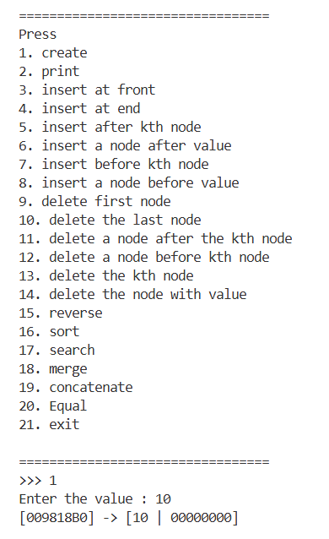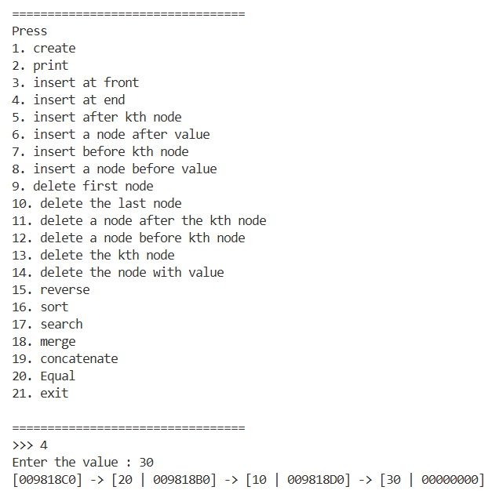
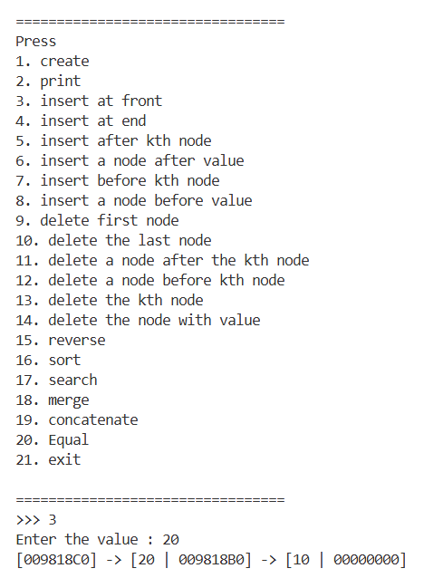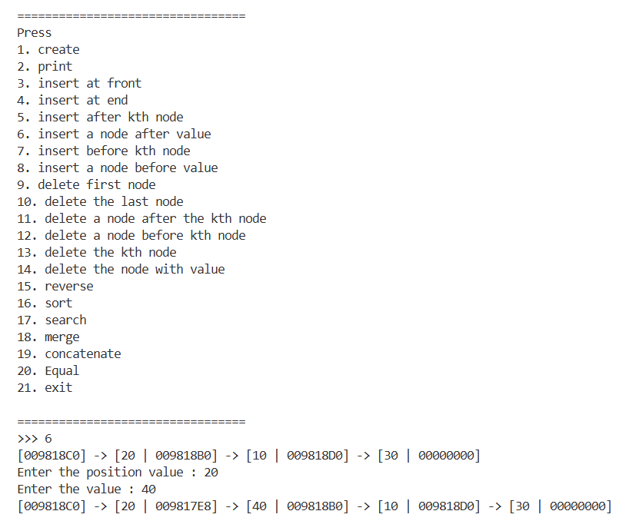

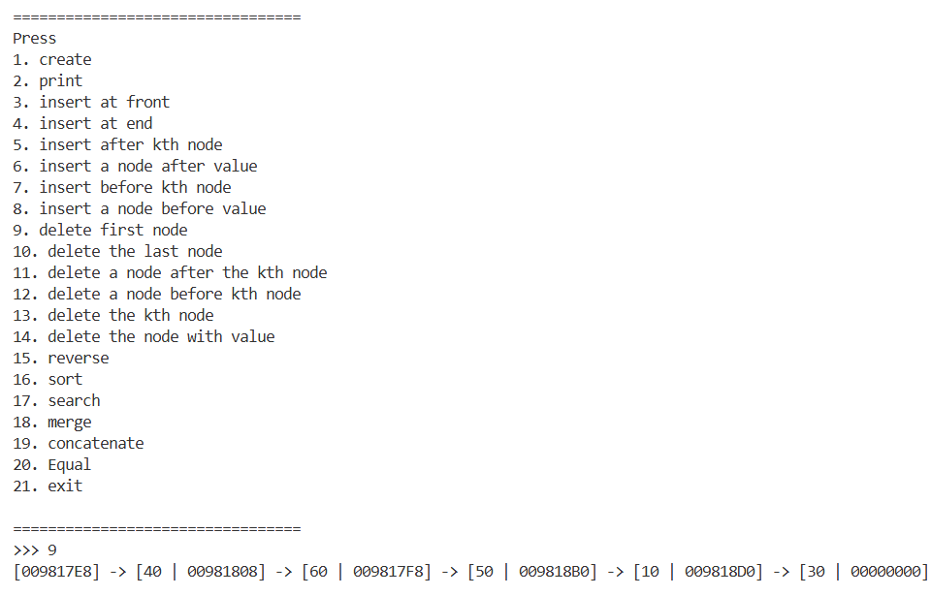
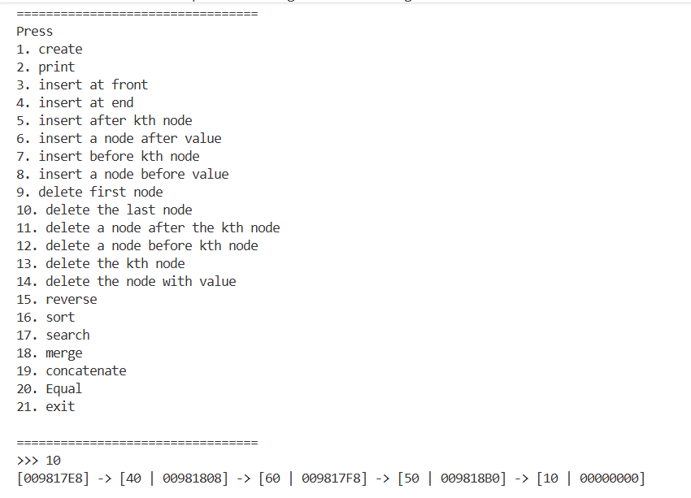
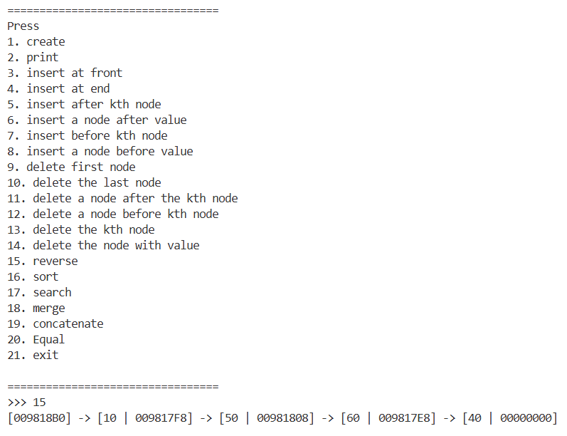
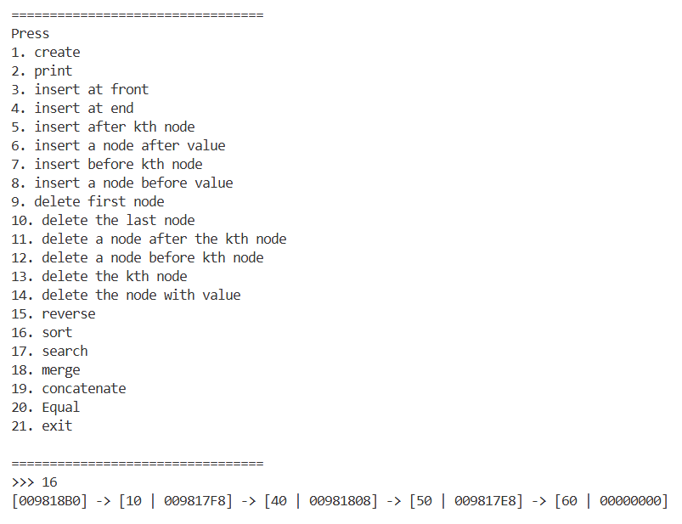
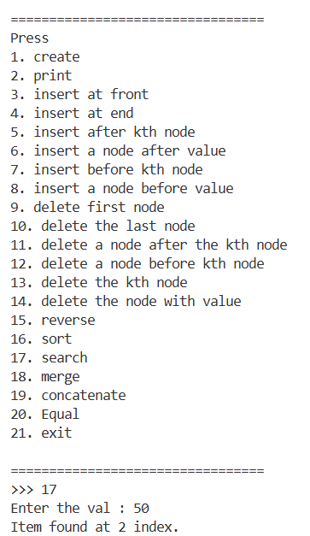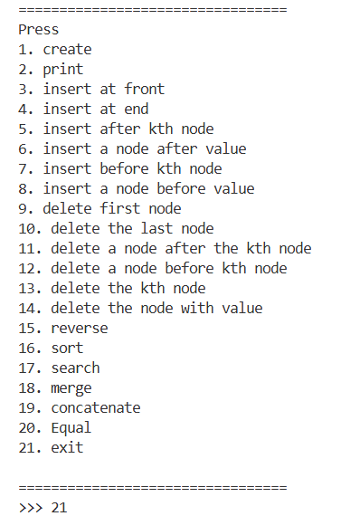

QUESTION 3 : Write a menu-driven program representing a polynomial as a data structure using a singly linked list and write functions to add, subtract and multiply two polynomials.

SOURCE CODE :
#include <stdio.h>
#include <stdlib.h>

typedef struct Node {
int cof;
int pwr;
char var;
struct Node *next;
} Node;

// Insert term in descending power order
Node* insertTerm(Node* head, int cof, int pwr, char var) {
if (cof == 0) return head;

Node *newNode, *temp, *prev;

temp = head;
while (temp != NULL) {
if (temp->pwr == pwr) {
temp->cof += cof;

if (temp->cof == 0) {
if (temp == head) {
head = head->next;
free(temp);
} else {
prev->next = temp->next;
free(temp);
}
}
return head;
}
prev = temp;
temp = temp->next;
}
newNode = (Node*)malloc(sizeof(Node));
newNode->cof = cof;
newNode->pwr = pwr;
newNode->var = var;
newNode->next = NULL;

if (head == NULL || pwr > head->pwr) {
newNode->next = head;
return newNode;
}
temp = head;

while (temp->next != NULL && temp->next->pwr > pwr) {
temp = temp->next;
}

newNode->next = temp->next;
temp->next = newNode;

return head;
}

// Create polynomial
Node* createPoly() {
int n;
printf("Enter number of terms: ");
scanf("%d", &n);

Node* head = NULL;

for (int i = 0; i < n; i++) {
int cof, pwr;
printf("\nTerm %d\n", i + 1);

printf("Coefficient: ");
scanf("%d", &cof);

printf("Power: ");
scanf("%d", &pwr);
head = insertTerm(head, cof, pwr, 'x');
}

return head;
}

// Display polynomial
void display(Node* head) {
if (head == NULL) {
printf("0\n");
return;
}
Node* temp = head;
int first = 1;

while (temp != NULL) {
if (!first && temp->cof > 0) printf(" + ");
if (temp->cof < 0) printf(" - ");
int coef = temp->cof < 0 ? -temp->cof : temp->cof;
if (temp->next == NULL) {
printf("%d", coef);
} else {
printf("%d%c^%d", coef, temp->var, temp->pwr);
}

first = 0;
temp = temp->next;
}
printf("\n");
}

// Addition
Node* add(Node* p1, Node* p2) {
Node* res = NULL;
while (p1 != NULL) {
res = insertTerm(res, p1->cof, p1->pwr, p1->var);
p1 = p1->next;
}
while (p2 != NULL) {
res = insertTerm(res, p2->cof, p2->pwr, p2->var);
p2 = p2->next;
}
return res;
}

// Subtraction
Node* sub(Node* p1, Node* p2) {
Node* res = NULL;
while (p1 != NULL) {
res = insertTerm(res, p1->cof, p1->pwr, p1->var);
p1 = p1->next;
}
while (p2 != NULL) {
res = insertTerm(res, -p2->cof, p2->pwr, p2->var);
p2 = p2->next;
}
return res;
}

// Multiplication
Node* mul(Node* p1, Node* p2) {
Node* res = NULL;
Node* t1 = p1;

while (t1 != NULL) {

Node* t2 = p2;
while (t2 != NULL) {
int coef = t1->cof * t2->cof;
int power = t1->pwr + t2->pwr;
res = insertTerm(res, coef, power, 'x');
t2 = t2->next;
}
t1 = t1->next;
}

return res;
}

// Free list
void freeList(Node* head) {
Node* temp;

while (head != NULL) {
temp = head;
head = head->next;
free(temp);
}
}

int main() {

Node *p1 = NULL, *p2 = NULL, *result = NULL;

int choice;

do {
printf("\n===== POLYNOMIAL MENU =====\n");
printf("1. Create Polynomial 1\n");
printf("2. Create Polynomial 2\n");
printf("3. Display Polynomials\n");
printf("4. Add\n");
printf("5. Subtract (P1 - P2)\n");
printf("6. Multiply\n");
printf("0. Exit\n");
printf("Enter choice: ");
scanf("%d", &choice);

switch (choice) {

case 1:
freeList(p1);
p1 = createPoly();
break;

case 2:
freeList(p2);
p2 = createPoly();
break;

case 3:
printf("\nP1 = ");
display(p1);

printf("P2 = ");
display(p2);
break;

case 4:
freeList(result);
result = add(p1, p2);

printf("\nP1 + P2 = ");
display(result);
break;

case 5:
freeList(result);
result = sub(p1, p2);

printf("\nP1 - P2 = ");
display(result);
break;

case 6:
freeList(result);
result = mul(p1, p2);

printf("\nP1 * P2 = ");
display(result);
break;

case 0:
printf("Exiting...\n");
break;

default:
printf("Invalid choice!\n");
}

} while (choice != 0);

freeList(p1);
freeList(p2);
freeList(result);

return 0;
}

OUTPUT :
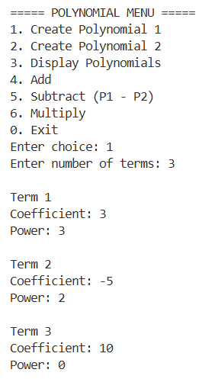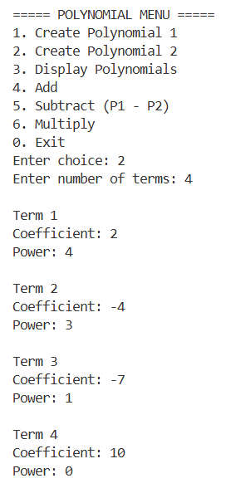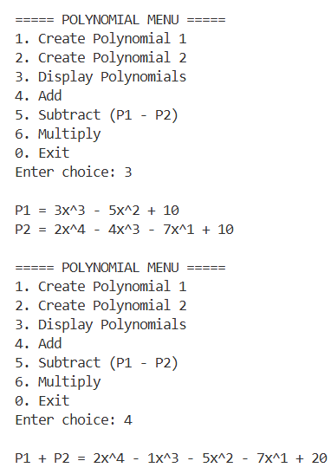
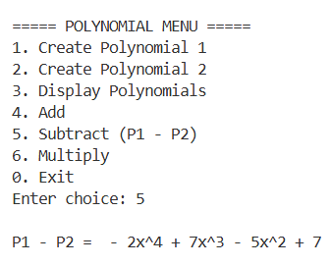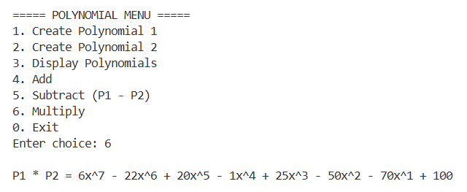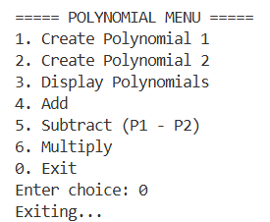
QUESTION 4 : Implement Doubly Linked List for the operations (I to XV)
I. Create a linked list.
II. Print the content of the list.
III. Insert an element at the front of the list
IV. Insert an element at the end of the list
V. Insert a node after the kth node.
VI. Insert a node after the node (first from the start) containing a given value.
VII. Insert a node before the kth node.
VIII. Insert a node before the node (first from the start) containing a given value.
IX. Delete the first node.
X. Delete the last node.
XI. Delete a node after the kth node.
XII. Delete a node before the kth node.
XIII. Delete the kth node.
XIV. Delete the node(first from the start) containing a specified value.
XV. Find the reverse of a list(not just printing in reverse)

SOURCE CODE :
#include <stdio.h>
#include <stdlib.h>

typedef struct Node {
int data;
struct Node *prev;
struct Node *next;
} Node;

// Create Node
Node* createNode(int data) {
Node* newNode = (Node*)malloc(sizeof(Node));
newNode->data = data;
newNode->prev = NULL;
newNode->next = NULL;
return newNode;
}

// I. Create Linked List
Node* createList() {
int n, data;
Node *head = NULL, *tail = NULL;

printf("Enter number of nodes: ");
scanf("%d", &n);

for(int i = 0; i < n; i++) {
printf("Enter data: ");
scanf("%d", &data);

Node* newNode = createNode(data);

if(head == NULL) {
head = tail = newNode;
}
else {
tail->next = newNode;
newNode->prev = tail;
tail = newNode;
}
}

return head;
}

// II. Display List
void display(Node* head) {
if(head == NULL) {
printf("List is Empty\n");
return;
}

printf("List: ");

while(head != NULL) {
printf("%d ", head->data);
head = head->next;
}

printf("\n");
}

// III. Insert at Front
Node* insertFront(Node* head, int data) {
Node* newNode = createNode(data);

newNode->next = head;

if(head != NULL)
head->prev = newNode;

return newNode;
}

// IV. Insert at End
Node* insertEnd(Node* head, int data) {
Node* newNode = createNode(data);

if(head == NULL)
return newNode;

Node* temp = head;

while(temp->next != NULL)
temp = temp->next;

temp->next = newNode;
newNode->prev = temp;

return head;
}

// V. Insert after kth node
Node* insertAfterK(Node* head, int k, int data) {
Node* temp = head;

for(int i = 1; i < k && temp != NULL; i++)
temp = temp->next;

if(temp == NULL) {
printf("Invalid Position\n");
return head;
}

Node* newNode = createNode(data);

newNode->next = temp->next;
newNode->prev = temp;

if(temp->next != NULL)
temp->next->prev = newNode;

temp->next = newNode;

return head;
}

// VI. Insert after value
Node* insertAfterValue(Node* head, int value, int data) {
Node* temp = head;

while(temp != NULL && temp->data != value)
temp = temp->next;

if(temp == NULL) {
printf("Value not found\n");
return head;
}

Node* newNode = createNode(data);

newNode->next = temp->next;
newNode->prev = temp;

if(temp->next != NULL)
temp->next->prev = newNode;

temp->next = newNode;

return head;
}

// VII. Insert before kth node
Node* insertBeforeK(Node* head, int k, int data) {
if(k == 1)
return insertFront(head, data);

Node* temp = head;

for(int i = 1; i < k && temp != NULL; i++)
temp = temp->next;

if(temp == NULL) {
printf("Invalid Position\n");
return head;
}

Node* newNode = createNode(data);

newNode->next = temp;
newNode->prev = temp->prev;

temp->prev->next = newNode;
temp->prev = newNode;

return head;
}

// VIII. Insert before value
Node* insertBeforeValue(Node* head, int value, int data) {
Node* temp = head;

while(temp != NULL && temp->data != value)
temp = temp->next;

if(temp == NULL) {
printf("Value not found\n");
return head;
}

if(temp == head)
return insertFront(head, data);

Node* newNode = createNode(data);

newNode->next = temp;
newNode->prev = temp->prev;

temp->prev->next = newNode;
temp->prev = newNode;

return head;
}

// IX. Delete First Node
Node* deleteFirst(Node* head) {
if(head == NULL)
return NULL;

Node* temp = head;

head = head->next;

if(head != NULL)
head->prev = NULL;

free(temp);

return head;
}

// X. Delete Last Node
Node* deleteLast(Node* head) {
if(head == NULL)
return NULL;

if(head->next == NULL) {
free(head);
return NULL;
}

Node* temp = head;

while(temp->next != NULL)
temp = temp->next;

temp->prev->next = NULL;

free(temp);

return head;
}

// XI. Delete node after kth node
Node* deleteAfterK(Node* head, int k) {
Node* temp = head;

for(int i = 1; i < k && temp != NULL; i++)
temp = temp->next;

if(temp == NULL || temp->next == NULL) {
printf("Deletion not possible\n");
return head;
}

Node* del = temp->next;

temp->next = del->next;

if(del->next != NULL)
del->next->prev = temp;

free(del);

return head;
}

// XII. Delete node before kth node
Node* deleteBeforeK(Node* head, int k) {
if(k <= 2) {
printf("Deletion not possible\n");
return head;
}

Node* temp = head;

for(int i = 1; i < k && temp != NULL; i++)
temp = temp->next;

if(temp == NULL || temp->prev == NULL) {
printf("Deletion not possible\n");
return head;
}

Node* del = temp->prev;

if(del == head) {
head = head->next;
head->prev = NULL;
free(del);
return head;
}

del->prev->next = temp;
temp->prev = del->prev;

free(del);

return head;
}

// XIII. Delete kth node
Node* deleteK(Node* head, int k) {
if(k == 1)
return deleteFirst(head);

Node* temp = head;

for(int i = 1; i < k && temp != NULL; i++)
temp = temp->next;

if(temp == NULL) {
printf("Invalid Position\n");
return head;
}

if(temp->next != NULL)
temp->next->prev = temp->prev;

temp->prev->next = temp->next;

free(temp);

return head;
}

// XIV. Delete node containing specified value
Node* deleteValue(Node* head, int value) {
Node* temp = head;

while(temp != NULL && temp->data != value)
temp = temp->next;

if(temp == NULL) {
printf("Value not found\n");
return head;
}

if(temp == head)
return deleteFirst(head);

if(temp->next != NULL)
temp->next->prev = temp->prev;

temp->prev->next = temp->next;

free(temp);

return head;
}

// XV. Reverse the List
Node* reverseList(Node* head) {
Node *temp = NULL;
Node *current = head;

while(current != NULL) {
temp = current->prev;
current->prev = current->next;
current->next = temp;

current = current->prev;
}

if(temp != NULL)
head = temp->prev;

return head;
}

// Free List
void freeList(Node* head) {
Node* temp;

while(head != NULL) {
temp = head;
head = head->next;
free(temp);
}
}

int main() {
Node* head = NULL;

int choice, data, k, value;

do {
printf("\n===== DOUBLY LINKED LIST MENU =====\n");
printf("1. Create List\n");
printf("2. Display List\n");
printf("3. Insert Front\n");
printf("4. Insert End\n");
printf("5. Insert After Kth Node\n");
printf("6. Insert After Value\n");
printf("7. Insert Before Kth Node\n");
printf("8. Insert Before Value\n");
printf("9. Delete First Node\n");
printf("10. Delete Last Node\n");
printf("11. Delete After Kth Node\n");
printf("12. Delete Before Kth Node\n");
printf("13. Delete Kth Node\n");
printf("14. Delete Value\n");
printf("15. Reverse List\n");
printf("0. Exit\n");

printf("Enter Choice: ");
scanf("%d", &choice);

switch(choice) {

case 1:
freeList(head);
head = createList();
display(head);
break;

case 2:
display(head);
break;

case 3:
printf("Enter data: ");
scanf("%d", &data);
head = insertFront(head, data);
display(head);
break;

case 4:
printf("Enter data: ");
scanf("%d", &data);
head = insertEnd(head, data);
display(head);
break;

case 5:
printf("Enter k and data: ");
scanf("%d%d", &k, &data);
head = insertAfterK(head, k, data);
display(head);
break;

case 6:
printf("Enter value and data: ");
scanf("%d%d", &value, &data);
head = insertAfterValue(head, value, data);
display(head);
break;

case 7:
printf("Enter k and data: ");
scanf("%d%d", &k, &data);
head = insertBeforeK(head, k, data);
display(head);
break;

case 8:
printf("Enter value and data: ");
scanf("%d%d", &value, &data);
head = insertBeforeValue(head, value, data);
display(head);
break;

case 9:
head = deleteFirst(head);
display(head);
break;

case 10:
head = deleteLast(head);
display(head);
break;

case 11:
printf("Enter k: ");
scanf("%d", &k);
head = deleteAfterK(head, k);
display(head);
break;

case 12:
printf("Enter k: ");
scanf("%d", &k);
head = deleteBeforeK(head, k);
display(head);
break;

case 13:
printf("Enter k: ");
scanf("%d", &k);
head = deleteK(head, k);
display(head);
break;

case 14:
printf("Enter value: ");
scanf("%d", &value);
head = deleteValue(head, value);
display(head);
break;

case 15:
display(head);
head = reverseList(head);
printf("List Reversed Successfully\n");
display(head);
break;

case 0:
printf("Program Terminated.\n");
break;

default:
printf("Invalid Choice!\n");
}

} while(choice != 0);

freeList(head);

return 0;
}

OUTPUT :
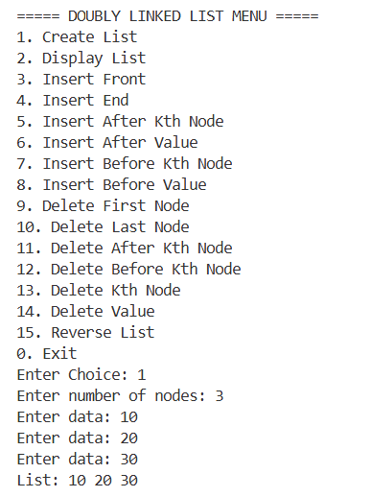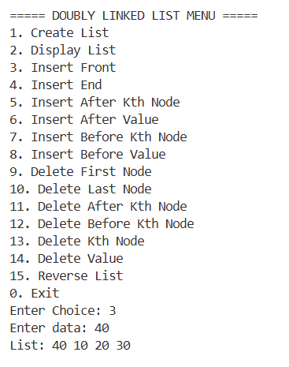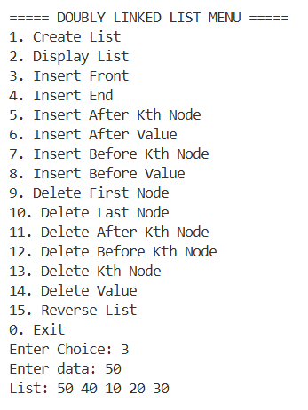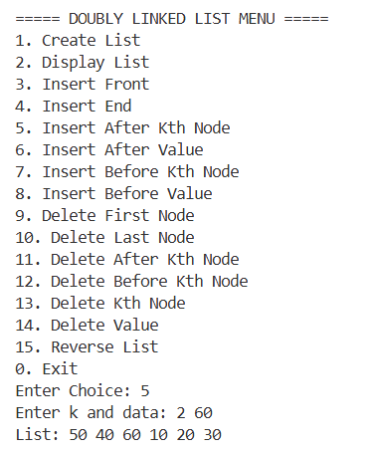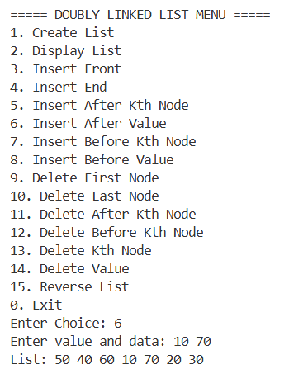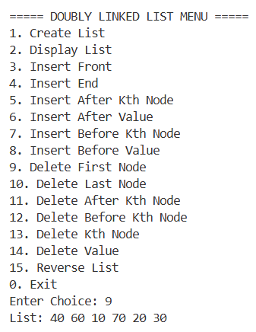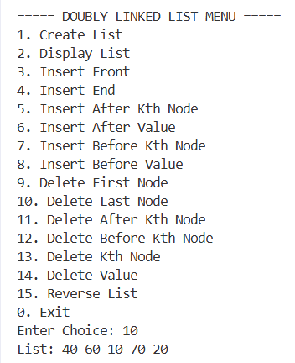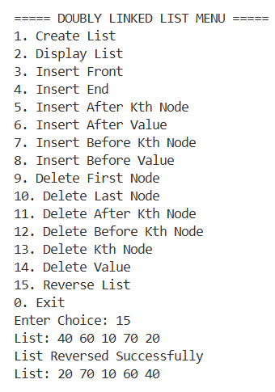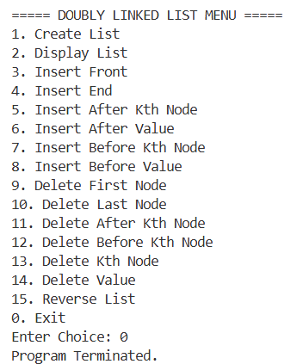

QUESTION 5: Given a problem, “people are standing in a circle waiting to be executed. Counting begins at a specified point in the circle and proceeds in a specified direction (e.g., clockwise). After a specified number of people is skipped, the next person is executed (i.e., removed). The procedure is repeated with the remaining people, starting with the next person, going in the same direction and skipping the same number of people until only one person remains and is freed”. The solution is to find the person to be freed. Solve it using
- 2D array
SOURCE CODE :
#include <stdio.h>
int josephusArray(int n, int k) {
int arr[n][2];
for(int i=0;i<n;i++) {
arr[i][0] = i+1;
arr[i][1] = 1;
}
int alive = n;
int pos = 0;
int count = 0;

while(alive > 1) {
if(arr[pos][1] == 1) {
count++;
if(count == k) {
arr[pos][1] = 0;
printf("Executed: %d\n", arr[pos][0]);
alive--;
count = 0;
}
}
pos = (pos + 1) % n;
}
for(int i=0;i<n;i++) {
if(arr[i][1] == 1)
return arr[i][0];
}
return -1;
}
int main() {
int n,k;
printf("Enter number of people: ");
scanf("%d",&n);
printf("Enter k: ");
scanf("%d",&k);
int survivor = josephusArray(n,k);
printf("Freed Person = %d\n",survivor);
return 0;
}

OUTPUT :
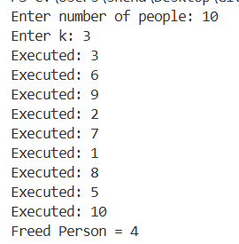

- A circular linked list.
SOURCE CODE :
#include<stdio.h>
#include<stdlib.h>
typedef struct Node{
int data;
struct Node* next;
}Node;
Node* createCircle(int n){
Node *head=NULL,*temp,*newNode;
for(int i=1;i<=n;i++) {
newNode=(Node*)malloc(sizeof(Node));
newNode->data=i;
newNode->next=NULL;
if(head==NULL) {
head=newNode;
temp=newNode;
} else {
temp->next=newNode;
temp=newNode;
}
}
temp->next=head;
return head;
}
int josephusCLL(int n,int k){
Node* head=createCircle(n);
Node *ptr=head;
Node *prev=NULL;
while(ptr->next!=ptr) {
for(int i=1;i<k;i++) {
prev=ptr;
ptr=ptr->next;
}
printf("Executed: %d\n",ptr->data);
prev->next=ptr->next;
Node* del=ptr;
ptr=ptr->next;
free(del);
}
int survivor=ptr->data;
free(ptr);
return survivor;
}
int main() {
int n,k;
printf("Enter n: ");
scanf("%d",&n);
printf("Enter k: ");
scanf("%d",&k);
printf("Freed Person = %d\n",josephusCLL(n,k));
return 0;
}
OUTPUT :
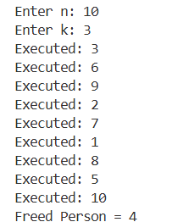

- A circular doubly linked list.
SOURCE CODE :
#include<stdio.h>
#include<stdlib.h>
typedef struct Node{
int data;
struct Node *prev;
struct Node *next;
}Node;
Node* createCDLL(int n){
Node *head=NULL,*last=NULL,*newNode;
for(int i=1;i<=n;i++) {
newNode=(Node*)malloc(sizeof(Node));
newNode->data=i;
if(head==NULL) {
head=newNode;
last=newNode;
} else {
last->next=newNode;
newNode->prev=last;
last=newNode;
}
}
head->prev=last;
last->next=head;
return head;
}
int josephusCDLL(int n,int k){
Node* ptr=createCDLL(n);
int count=n;
while(count>1){
for(int i=1;i<k;i++)
ptr=ptr->next;
printf("Executed: %d\n",ptr->data);
ptr->prev->next=ptr->next;
ptr->next->prev=ptr->prev;
Node* del=ptr;
ptr=ptr->next;
free(del);
count--;
}
int survivor=ptr->data;
free(ptr);
return survivor;
}
int main(){
int n,k;
printf("Enter n: ");
scanf("%d",&n);
printf("Enter k: ");
scanf("%d",&k);
printf("Freed Person = %d\n",josephusCDLL(n,k));
return 0;
}
OUTPUT :
